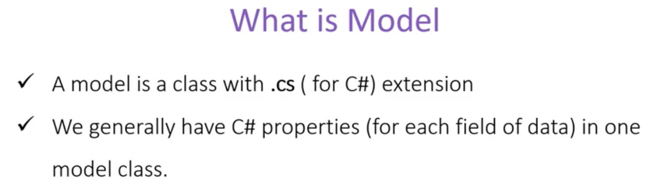

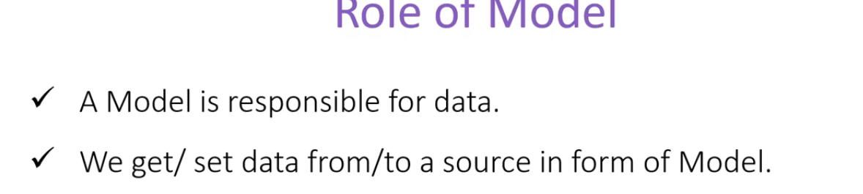

Putting the Model classes in model folder is not a must. We can rename to any other folder name or we can create a class library project and add reference to that class library to current project and we can access all the models from the class library as well. We can even put more folder inside the Model folder and organize our models as per needs.

